Merrill-Palmer-Revised (M-P-R)
Scales of Development

Changes in this edition:
- Updated tasks
- New, nationally representative norms
- Expanded item sets for better coverage of key dimensions
- Elimination of items requiring a high level of expressive language
- Replacement of small objects with "choke-safe" manipulatives
- A training DVD
The Merrill-Palmer-Revised is a global developmental assessment, with scores for each IDEA domain.
The M-P-R meets the requirements of federal legislation for early identification of developmental delays and learning difficulties.
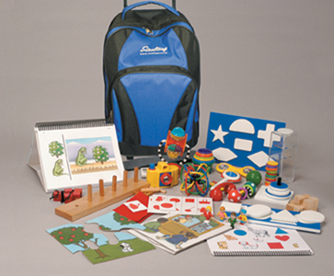

Merrill-Palmer-Revised (M-P-R)
Scales of Development
by Gale H. Roid, Ph.D., and Jackie L. Sampers, Ph.D.

Revised and expanded, this edition of the Merrill-Palmer Scales of Development retains the kind of engaging "hands-on" activities that made previous versions of the test so popular with early childhood assessment specialists. These toy-based activities hold the interest of even very young or distractible children, allowing you to do a comprehensive developmental evaluation in just 45 minutes.
Appropriate for children from 1 month to 6 1/2 years of age, the M-P-R assesses all IDEA-specified domains:

- Cognitive Development
- Language/Communication
- Motor Development
- Social-Emotional Behavior
- Self-Help/Adaptive Behavior

These domains are assessed through performance tasks and activities as well as parent and examiner rating scales. For each domain, the M-P-R provides standard scores, percentiles, age equivalents, and "growth scores" that reflect even small incremental changes. When these scores are plotted on the M-P-R Growth Score Profile, it's easy to spot the child's specific deficits. Norms are based on a nationally representative sample of more than 1,000 children. A training DVD offers administration and scoring instructions plus interpretive guidance.
M-P-R results can be used to:

- Identify developmental delays early in a child's life
- Monitor premature infants, using the highly sensitive Growth Scores
- Measure incremental improvement in children up to 6 1/2 years
- Assess youngsters with hearing impairments, autism, or limited language skills
- Provide the kind of comprehensive assessment required by IDEA for Family Service Plans and Individual Education Plans (IEPs)

The M-P-R comes in a convenient, portable travel case with wheels. All toys and manipulatives are "choke-safe."

Component
KIT: Includes Administration/Scoring Manual; Infant Stimuli Book; Easel Book, Fido Book; Choke-Safe Toys and Manipulatives; and 20 each of all necessary Forms in a convenient Rolling Bag

