WLOS: Written Language Observation Scale

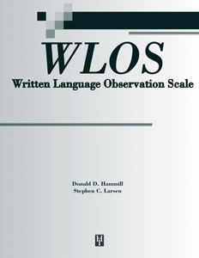

Ages: 9-0 to 17-11
Testing Time: 5-10 minutes
Administration: Individual

The Written Language Observation Scale (WLOS) is a 25-item, norm-referenced teachers’ rating scale that can be used to assess students’ daily classroom writing behaviors. The WLOS is normed on a sample of 1,122 persons in 13 states and has proven reliability and validity (including evidence of sensitivity and specificity). Its items relate to specific writing behaviors readily seen in instructional settings (e.g., “enjoys writing,” “uses acceptable grammar”). Teachers or other knowledgeable professionals rate the items on a 5-point scale. The WLOS can be used to (a) support a referral, (b) expand the scope of a comprehensive written language evaluation, (c) compare teachers’ ratings with test results, (d) help plan interventions, and (e) monitor the effectiveness of interventions. Results are particularly useful when used as part of a comprehensive written language evaluation or as a pre-referral/referral tool.
COMPLETE WLOS (©2009) KIT INCLUDES:
- Examiner’s Manual
- 50 Summary/Rating Forms
- all in an organized folder. (©2009)

