A Functional Assessment & Curriculum for Teaching Students with Disabilities —

Volumes I-IV

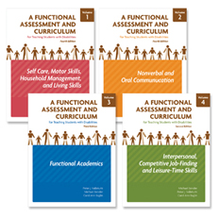
Target Group: Infancy through Young Adult
Now substantially revised and available in four volumes, these books are intended as a guide for educators, special education teachers, school administrators, counselors, and other professionals involved in rehabilitation services for individuals with disabilities.
Newly added is the instrument Assessing and Monitoring Progress of Functional Skills (AMPFS), which helps teachers target skills for instruction and measure progress toward skill mastery.
Included are suggested activities that are divided into two major categories:
- Teacher Interventions
- Family Interventions

These two categories are then divided into four subcategories of distinct age/grade levels:
- Infant (Birth through 2 years) and Toddler/Preschool (3 to 5 years)
- Primary
- Intermediate
- Secondary
All units within each volume comprise specific goals, related references, suggested readings, and selected materials/resources.
- Volume I: Self-Care, Motor skills, House Management, and Living Skills — 4th Ed.
- Volume II: Nonverbal Communication, Oral Communications, and Literacy Preparation — 4th Ed.
- Volume III: Functional Academics — 3rd Ed.
- Volume IV: Interpersonal, Competitive Job-Finding, and Leisure-Time Skills — 2nd Ed.
All Volumes: ©2008 • 8.5 x 11 • lay-flat binding with reproducibles

