Conversations with Conjunctions

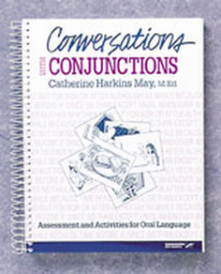

Assessment and Activities for Oral Language

TARGET GROUP: 7-18 years
Focus on conversational strategies to help your students practice and master the use of conjunctions in oral language. Give them a solid base on which to build their reading and writing skills. Use this program to help students better understand classroom discourse and textbooks.
Use the pre- and posttests to find out what students need to work on. You'll have lessons to target:
- Coordinating Conjunctions-and, but, for, nor, or, yet
- Subordinating Conjunctions-after, so that, in order that, although, through, than, as, as if, as long as, unless, because, until, before, when, whenever, if, where, wherever, since, while
- Correlative Conjunctions-both...and, either...or, neither...nor, not only...but also, whether...or
Reinforce the use of conjunctions with a variety of methods that encourage active learning and provide instant feedback. Plus, make use of American Sign Language (ASL) to teach the meaning of each conjunction. This unique approach allows you to present abstract words in visual, concrete terms.
Look at all the ways you'll have to involve students in conversation building activities:
- 25 ASL signs
- 144 reproducible stimulus picture cards
- Reproducible gameboard
- Short narratives and story starters
- Reproducible worksheets
- Reproducible parent and teacher letters

COMPLETE PROGRAM: Manual, stimulus cards, game cards, reproducible gameboard

