DAR™-2 Classroom Kit Form B with TTS

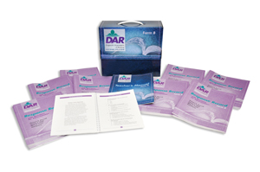
COMPLETE DAR-2 CLASSROOM FORM A INCLUDES:
- Teacher’s Manual B
- Student Book B
- 30 Response Record Forms - B
- and TTS for Five Users
©2006

DAR™-2 Classroom Kit Form A with TTS

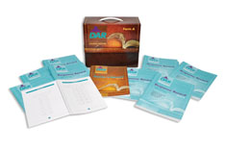

COMPLETE DAR-2 CLASSROOM FORM A INCLUDES:
- Teacher’s Manual A
- Student Book A
- 30 Response Record Forms - A
- and TTS for Five Users
(©2006)

