Dynamic Assessment and Intervention: Improving Children's Narrative Abilities - Complete Program

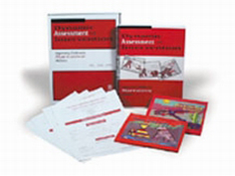

Target Group: Children and students who need help developing narrative abilities

Dynamic Assessment and Intervention: Improving Children's Narrative Abilities is the first practical guide for evaluating children's narrative abilities and providing intervention using dynamic assessment and mediated learning. The manual takes you through the assessment and intervention processes step by step, showing you:
- how to collect and score stories using the wordless picture books provided;
- how to conduct dynamic assessment sessions to determine the student's responses to a supportive narrative learning experience;
- how to determine whether the student would benefit from additional mediated learning sessions; and
- how to conduct intervention sessions using the principles of mediated learning.
The step-by-step manual is accompanied by
- worksheets that guide you through story collection and scoring
- worksheets that show you how to design and conduct both assessment and intervention sessions
- a Student Protocol Booklet for easy recording and scoring of stories
- two full-color wordless picture books for eliciting stories
- complete descriptions of how the entire assessment and intervention process worked with three students from different backgrounds and ability levels
- numerous figures and tables that provide clear illustrations of both the assessment and the intervention process

Complete Program Includes: Manual, 10 Student Protocol Booklets, and 2 Storybooks, all in a sturdy storage box. ©2001

