Dysarthria Rehabilitation — Second Edition

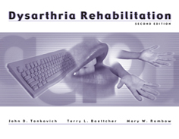

Target Group: Adolescents and Adults

Based on positive feedback from clinicians who used the original edition of this program, we have revised the Dysarthria Rehabilitation Program to better meet the needs of adolescent and adult clients with dysarthric speech. Among the improvements, you'll find that we've extensively updated the illustrations, and packaged them in a bound, easel-backed stimulus manual that makes it easier to keep them together as you travel. The stimulus items also have been updated to better reflect the needs, interests, and experience of those who have dysarthria. Includes new guidelines for use by assistants and caregivers.
This program is still easy to administer and flexible enough to meet the individual needs of clients with dysarthria. Exercises are arranged in a hierarchy from simple to complex. The program contains exercises divided into three sections:
- Exaggerating Articulatory Movements
- Reducing Speech Rate Via Vowel Prolongation
- Improving Speech Prosody
All necessary stimuli, including words, 60 pictures, and data and tracking forms, are included in this comprehensive program.
COMPLETE PROGRAM INCLUDES: Manual, Stimulus Manual, and Reproducible Data Collection and Tracking Forms

