Early Aphasia Therapy

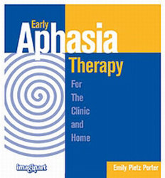

For the Clinic and Home You'll love the results you get using from this structured, easy-to-use, picture-based aphasia program. It features:
- A hierarchy of difficulty — from singing and rhythm, to automatic speech, phrase completion, confrontational sentence formulation, and finally responsive and open-ended sentence formulation — allows you to increase difficulty systematically.
- A standard cueing sequence adds consistency (picture alone, picture + some letters, picture + printed word or sentence). These cues can be progressively uncovered on the page until the client responds correctly. Additional cues are suggested if this sequence does not always work.
- Complete instructions are provided for both the SLP and caregiver, so it's easy to copy and use as a home program. Family members can learn cueing techniques they can use in everyday situations.
- Large print and clear Pick 'n Stick® illustrations are easy for clients to identify and are age-appropriate for adults.

This one book has everything you'll need to jump start your client's recovery.

