Early Communication Games

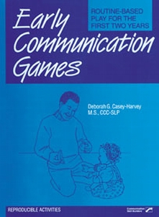

Routine-Based Play for the First Two Years

Encourage infants from birth to 24 months old to develop beginning communication skills with this collection of family-centered activities. Use the reproducible handouts to include parents, family members, and caregivers as active members of the educational team. Early Communication Games comes complete with a set of goals for the child's development. This is an ideal resource for bridging the gap between assessment and development of functional goals on the IFSP.
Separate lists of skills are provided for children functioning at 0-12 months and for those functioning at 12-24 months. Formulate a customized communication skill plan for each child, and use it wherever you normally conduct therapy. Get parents involved in both the activities and the evaluation process.
Games include clear directions and useful activity sheets. Three skill areas are developed:
- Awareness — games like "Look at Me," "On and Off with Music," and "Hand or Finger Puppets"
- Imitation — games like "Mirror Talk," "Rhythm Activities," and "Familiar Routines"
- Concepts — games like "Object Permanence and Cause and Effect," "Exploring Paper," "Holiday Ideas," and more!

Enjoy using these thoroughly explained, reproducible games. You'll find the numerous activities described in the specific, user-friendly terms of parents. Teach parents to turn daily activities into opportunities for learning. These games are a good addition to your clinical practice.

