Edmark Reading Program Software – Levels 1 & 2 School Combo Kit

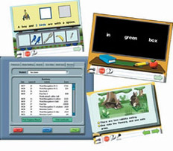

Regarded as "the one that works" by many teaching professionals, this software can be used independently or with the Edmark Reading Program print version, providing educators with another excellent tool to help students achieve reading success. The print and software versions have exactly the same lesson structure in exactly the same sequence; both address multiple learning styles and create varied activities that fully engage students.
Throughout the software lessons and activities, high-quality audio cues, colorful graphics, short instructional steps, repetition, and constant positive feedback are provided. This independent learning structure builds self-confidence in students and is especially effective for developing independent skills and placing students with special needs into inclusive classrooms and integrated settings. Students can use a variety of devices to interact with the program, including the TouchWindow®, a mouse, alternate keyboards, and single switches.
Level 1 Software offers:
- 29 colorful, multipage stories
- 150 Words from the Doch Word List and basal readers, including endings: -s, -ing, -ed
- Printable Flash Cards and Signing Manual
Level 2 Software offers:
- 100 colorful, multipage stories
- 200 words, including compound words and review of words learned in Level 1
- Printable Flash Cards and Comprehension Questions

Save by purchasing a pack!
Which package is right for me?

Home Edition is for home use only, and consists of 1 CD which tracks the progress of two learners.
School Version is a 2-CD pack. (Each CD tracks the progress of 100 learners.)
Lab Pack is a 6-CD pack.
Site License is a 35-CD pack.
Network License is recommended for networked users.

