Edmark Reading Program Supplemental Materials: Level 2 Homework

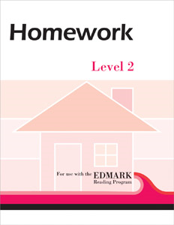

Edmark Reading Program Supplemental Materials
Use these reproducible worksheets with students who have completed the first level of the Edmark Reading Program and have progressed to Level 2. These lessons provide the student with practice of new words as they are learned. The lessons are short an engaging and can be completed with little or no assistance. They include activities such as Sentence Writing, Read & Match, Word Search, Meaning Match, Word Sun, and more. Introductory and closing Parent Notes briefly explain what is required of parents. A Student Performance Chart is also included to help keep track of homework progress.

