Evaluating and Improving Written Expression — Third Edition

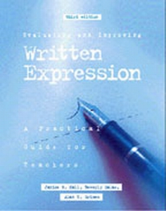

A Practical Guide for Teachers
Evaluating and Improving Written Expression is designed to give teachers and students an overview of “what makes good writing.” The concepts and activities are designed for use by regular classroom teachers, resource room teachers, and anyone else interested in helping students improve their writing ability. Informal evaluation procedures and numerous writing samples assist teachers in analyzing student writing by pinpointing strengths and weaknesses.
This book is a detailed, practical approach to assessment, program planning, and management with more than 190 ready-to-use worksheets, activities, and techniques emphasizing vocabulary, motivation, and evaluation. The new edition has added activities, as well as an updated computer chapter including world wide web resources.
Part I — Prewriting
- Chapter 1: Introduction
- Chapter 2: Check Their Writing

Part I — Writing
- Chapter 3: Get Them Writing
- Chapter 4: Use the Computer
- Chapter 5: Let Them Write Creatively
- Chapter 6: Write for a Reason
- Chapter 7: Get It Organized
- Chapter 8: Use the Right Word
- Chapter 9: Build Sentence Sense

Part III — Postwriting
- Chapter 10: Tackle the Troublespots
- Chapter 11: Check Their Spelling
- Chapter 12: Improve Their Handwriting

