Improving Function in Dementia and Other Cognitive-Linguistic Disorders

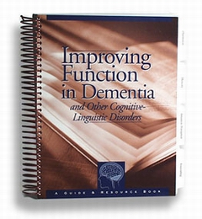

A Guide and Resource Book
If you work with dementia patients, this guide and resource book will become your clinical bible. Not only do Bayles and Tomoeda specify guidelines for delivering services to demetia patients, they discuss assessment, and how to analyze test performance and write treatment goals.
The authors explain techniques for maximizing and improving the functioning of dementia patients and provide a wealth of photocopiable tasks and exercises for working on:
- ADLs
- Associating
- Attention/Perception
- Categorizing
- Cognitive-Linguistic Skills
- Memory
- Orientation
- Reading/Writing/Drawing/Gestures
- Sequencing
Chapter Topics include:
- Dementia and Cognitive-Linguistic Disorders
- Guidelines for providing reimbursable services
- Tests of Functional Abilities of Dementia Patients
- Assessing Communicative Function in Patients with Dementia
- Functional Abilities of Alzheimer's Patients By Stage of Disease
- A Model for Successful Intervention
- Interpreting Test Performance and Writing Treatment Goals
- Interventions for Improving Function (reproducible section)

