Multiple Meanings for the Young Adult

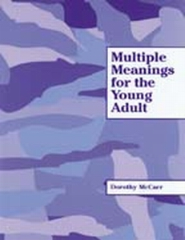
Multiple Meanings for the Young Adult includes motivational, fun exercises that help older students build a meaningful vocabulary. The exercises focus on common words that have many different meanings. It is designed for the older, mature student (middle school through adulthood) who is reading at approximately a second- or third-grade level. Eighty common, practical words found in newspapers, magazines, and texts are included in the book. Twenty lessons each include four words, with three exercises for each word. Each of the four words in the lesson has from 4 to 10 definitions. An answer key is included at the back of the workbook for students who are capable of working independently; it also may be removed by the instructor.

