Practical Ideas That Really Work for English Language Learners

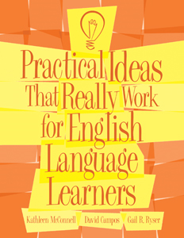

The instructional ideas presented in this kit are specially designed for teaching 4th - 12th grade students served in programs for English Language Learners (ELL), limited English proficient (LEP), and English as a second language (ESL). The kit includes a quick, easy to use criterion-referenced rating scale, an ideas matrix, and 37 research-based strategies to improve students' skills in listening, speaking, reading, writing and cultural awareness.

The rating scale:
• evaluates behaviors that interfere with learning and social interactions
• uses behavioral terminology from the No Child Left Behind Act definition of LEP
• relates the behaviors to ESL Standards for PreK-12 developed by TESOL

The matrix:
• quickly identifies which ideas will target selected behaviors
• offers multiple ideas for each behavior

The ideas:
• include a one-page explanation of each of the 37 ideas
• list handy tips to increase each idea's effectiveness
• provide helpful illustrations and examples
• offer reproducible masters for most ideas

Complete Kit includes Manual and 10 Evaluation Forms. (©2006)

