Ready, Set, Go!

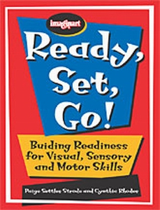

Here is a brand new book that addresses the most basic skills needed for success in the classroom and daily living. Where other resources teach early writing, dressing, and cutting skills such as drawing lines, snipping with scissors, and completing dressing cards, Ready, Set, Go! focuses on the foundation skills required prior to attempting to teach a child with a disability even the earliest writing, dressing and scissors tasks. By not addressing these foundation skills, many parents and professionals end up teaching skills in isolation. For example: trying to teach three year old children to draw a horizontal line when they do not have the necessary strength in his hand muscles to hold a pencil in a functional way.

Ready, Set, Go! is for children whose cognitive or developmental age is between six months and six years. This is the ideal time to teach basic foundation skills because the child is neurologically, cognitively, and academically ready for these activities. Over 90 fun foundation activities are divided into these sections:

- visual skills
- head/neck and trunk control
- upper extremity control
- pelvic and lower extremity control
- attention, sensory issues, and environment

The appendix is full of helpful information: a grid showing all the areas (vision, upper extremity, etc.) that an activity addresses; recipes for common therapy materials (slime, play dough, etc.); a developmental checklist divided by age in months, and more. OTs, PTs, speech pathologists, teachers, early interventionists, and parents of children with disabilities will all find this book a valuable resource.

