Right-Line Paper: The Paper with Raised Lines

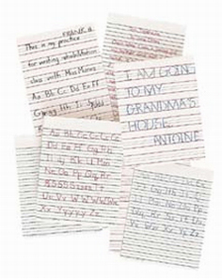
Right-Line Paper is a unique product designed to be used by individuals who have difficulty staying in the lines of regular writing paper. Both children and adults can benefit from this transitional writing tool. This unique paper provides immediate feedback and seems to help motivate students to improve their writing skills.

Right-Line Paper has a raised line superimposed on the printed line. This raised line stimulates proprioceptive feedback-the writer can feel the line. The printed line is green in order to distinguish it from pencil or pen marks.
The 8.5" x 11" bright white paper comes in a narrow and wide rule. The wide-rule paper has a dashed line between each raised line to be used as a guide for letter formation.
Designed for children with learning disabilities, individuals with orthopedic disabilities or partial sight, and adult rehabilitation patients

