Swallow Right—Second Edition

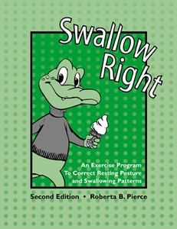

An Exercise Program to Correct Resting Posture and Swallowing Patterns

Take Advantage of theory, treatment, and tracking for your clients with tongue thrust!
The second edition of this practical program contains all you need for the evaluation and treatment of oral myofunctional disorders. Swallow Right is a tongue thrust correction program useful for young children, adolescents, and adults, in both individual and small-group therapy. The manual is divided into five parts:
- Introduction to the definition, etiology, anatomy, diagnosis, and treatment of tongue thrust swallowing patterns and resting postures
- Clinical procedure notes for the therapist to accompany each lesson
- 12 therapy lessons for young children
- 12 therapy lessons for adolescents and adults
- Appendices that include forms and logs useful during therapy, as well as suggestions for eliminating thumb and finger sucking and nail biting
Make the most of your time and encourage effective treatment with this easy-to-use format. Involve parents in treatment by using the reproducible activities in home carryover programs.

