Thank You for Calling — Revised Edition

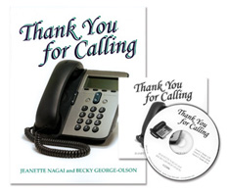

NEW CD Version!

Now available on an easy to use CD, this program will help your students or clients with aphasia or brain injury gain confidence in their ability to make and receive phone calls. Also great for ESL learners. Use the manual and audio CD to easily find appropriate exercises to challenge clients to listen for details, identify key auditory information, and use strategies for recall.
This innovative audio product challenges clients to listen for details, identify key auditory information, and use strategies for recall. The Auditory Processing unit presents 60 realistic phone messages. Messages from several types of businesses tell about hours, location, movie show times, and the like. There are also several messages such as might be found on a personal answering machine. The messages range from one sentence to paragraph length. The follow-up questions range from yes/no to open-ended, to cognitively challenging. The Verbal Expression unit is designed for role-playing phone calls‹a great activity in a group. For each scenario‹e.g., calling a shoe repair shop, an optician, a pizza place‹there is a list of information the client is to find out. The manual provides scripts for the audio messages, complete instructions, suggested compensatory strategies, and carryover suggestions to do at home.
Manual • CD • ISBN-13: 978-1-4164-0344

