The Big Book of Sounds — Fifth Edition

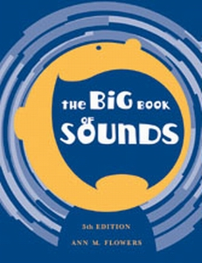

The fifth edition of Big Book of Sounds has been organized with the speech-language clinician in mind. It includes easily-accessible remediation procedures, such as:
- Special identification of the phoneme and the auditory discrimination of the sound
- Suggestions for isolated production of the phoneme and client imitation of the pattern presented by the clinician
- Syllable drills
- Syllable rhymes
- Word menus by category (e.g., people, things, places, food, creatures, etc.)
- Rhyming
- Short Sentences
- Word menu enhancement
- Nursery rhymes, riddles, and idioms
- Tables with examples of syntactic structures and a menu of pronouns in common use
The materials in this book were gathered to give the clinician much-needed help in designing interesting therapy sessions. With the arduous burden of collecting therapy materials lightened, each session may be a pleasurable experience for the clinician as well as for the client.

