The Voice Diagnostic Protocol

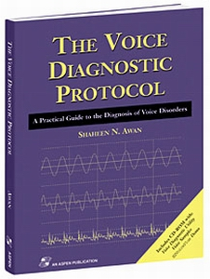

A Practical Guide to the Diagnostic of Voice Disorders This practical manual, intended for both students and clinicians, provides detailed information regarding the rationale and procedures for an array of readily available, relatively low-cost methods of voice analysis that are collectively called the "Voice Diagnostic Protocol." The book focuses on how to do a comprehensive assessment of voice function, incorporating history-taking; perceptual analysis; objective analysis of vocal frequency, intensity, and quality; examination of structures; evaluation of respiratory and phonatory ability and control; and evaluation of the possible effects of excessive muscular tension. Each diagnostic procedure covered includes a discussion of its purpose, its theoretical basis, guidelines for use, related normative data, and interpretation of possible abnormal responses. Case studies, an electronic tutorial with actual voice samples, and an extensive list of references enhance in-depth study.

Contents
- Evaluation of Vocal Pitch/Frequency
- Evaluation of Vocal Loudness/Intensity
- Evaluation of Vocal Quality
- Evaluation of Duration: Respiratory/Phonatory Control
- Evaluation of Muscle Tension Dysphonia
- Conclusions and Case Studies
- References
- Appendix A — Contact Information for Various Software and Equipment Manufacturers
- Appendix B — Perceptual Evaluation of the Voice: Record Form
- Appendix C — Quantitative Evaluation of the Voice: Record Form
- Appendix D — The Rainbow Passage
- Appendix E — Using the Hertz-to-Semitone Converter Program
202 pages • 2000 • softcover • ISBN 0834217171

