Therapeutic Activities with Persons Disabled by Alzheimer's Disease and Related Disorders

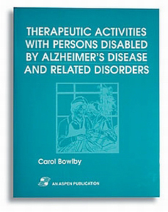

This is a must have for all who work with persons with Alzheimer's disease and related disorders. It provides extensive hands-on activities and the essential background information that will allow staff to understand and work with this population. A complete working guide, each section of activities provides related research, general principles and methods, detailed plans for specific activities, and suggested resources. This all-around resource also includes a chapter on administrative and reimbursement issues.

