Rey Auditory Verbal Learning Test
A Handbook
by Michael Schmidt, Ph.D., ABPP, ABPN

  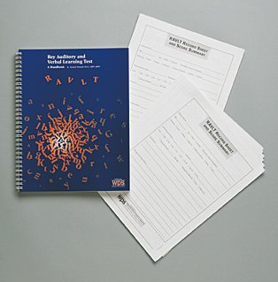
  "It's a relief having all the norms in one place and handled intelligently.
  I'm also pleased to see all the alternate lists--including French and German.
  A very useful product."
  Muriel D. Lezak, Ph.D.
  Author, Neuropsychological Assessment
  At a Glance
  Purpose: | A definitive guide to the Rey Auditory Verbal Learning Test, bringing together all versions and forms, psychometric data, research, and administration and scoring instructions in a single volume
  Ages / Grade: | 7 to 89 years
  Format: | Handbook plus Record Sheet and Score Summary
  Related Products
  Hooper Visual Organization Test (VOT)
  Stroop Color and Word Test
  Symbol Digit Modalities Test (SDMT)

Here is a comprehensive manual for the Rey Auditory Verbal Learning Test (RAVLT). This handbook brings together everything the clinician needs to know about this widely used neuropsychological test.
Originally developed in the 1940s, the RAVLT has evolved over the years, and several variations of the test have emerged. The standard RAVLT format starts with a list of 15 words, which an examiner reads aloud at the rate of one per second. The patient's task is to repeat all the words he or she can remember, in any order. This procedure is carried out a total of five times. Then the examiner presents a second list of 15 words, allowing the patient only one attempt at recall. Immediately following this, the patient is asked to remember as many words as possible from the first list.
The RAVLT has proven useful in evaluating verbal learning and memory, including proactive inhibition, retroactive inhibition, retention, encoding versus retrieval, and subjective organization. Because the test is brief, straightforward, easy to understand, and appropriate for both children and adults (ages 7 through 89), it has gained widespread acceptance. However, until now, data about the RAVLT-norms, validity studies, different administration and scoring procedures-have been scattered in various sources.
What this handbook provides is a definitive guide to the RAVLT-in a single volume. It describes the test, its development, and its use, covering the following topics in detail:
- Administration and Scoring
- Selecting Appropriate Norms and Forms
- Interpretation
- Moderator Variables (Age, Education, Intelligence, Gender, Ethnicity, Culture, and Clinical Diagnosis)
- Impaired Motivation and Malingering
- Alternate Forms and Test-Retest Comparisons
- Reliability and Validity
Appendixes include test forms and stimulus sheets, supplementary scores and indexes, and conversion tables for obtaining z-scores, T-scores, standard scores, and approximate percentiles. In addition, a 4-page Record Sheet and Score Summary, available with the Handbook or separately, allows you to quickly organize and record RAVLT special scores and indexes.

Component
KIT: Includes Handbook; 25 Record Sheet and Score Summaries

