Reynolds Adolescent Depression Scale, Second Edition (RADS-2)
William M. Reynolds, Ph.D.

  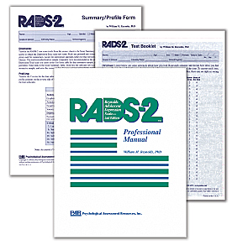
  Related Products
  Multiscore Depression Inventory for Children (MDI-C)
  Suicide Probability Scale (SPS)
  Children's Depression Inventory (CDI)
  Children's Depression Rating Scale, Revised (CDRS-R)
This popular self-report inventory is an excellent way to screen for depressive symptoms in adolescents. The Second Edition offers the following new features:
- Updated norms derived from a large, school-based sample
- An expanded age range (11 to 20 years)
- 4 factor-derived subscales reflecting basic domains of adolescent depression
- Standard scores and percentile ranks for total and subscale scores
- Case studies illustrating interpretation
- A carbonless, hand-scorable Test Booklet

Administered in just 5 to 10 minutes, the RADS-2 includes 30 items written at a 3rd-grade reading level and cast in the present tense to elicit current symptom status. These items cover the following dimensions:
- Dysphoric Mood
- Anhedonia/Negative Affect
- Negative Self-Evaluation
- Somatic Complaints
In addition to subscale scores, the RADS-2 yields a total score and empirically derived clinical cutoff scores. These indicate severity of symptoms (normal, mild, moderate, or severe), while item endorsement levels within subscales reflect the nature of an adolescents reported symptoms. Six critical items alert clinicians to the possibility that an adolescent may be experiencing a significant level of depression, even though his or her total score is below the clinical cutoff.
Restandardized on an ethnically diverse sample of 3,300 adolescents, ages 11 to 20, from schools in the U.S. and Canada, the RADS-2 provides T-scores and percentile ranks for the entire group and for subgroups stratified by gender and age (11-13, 14-16, and 17-20 years).
Extensive documentation of reliability and validity is provided in the test manual.

Component
KIT: Includes Manual; 25 Hand-Scorable Test Booklets; 25 Summary/Profile Forms

