PreBERS: The Preschool Behavioral and Emotional Rating Scale

NEW!

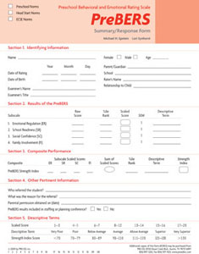

Ages: 3 through 5 years
Testing Time: 10 minutes
Administration: Individual
Designed for use in preschool, Head Start, and early childhood special education settings, the Preschool Behavioral and Emotional Rating Scale (PreBERS) is a standardized, norm-referenced, 42-item rating scale designed to assess the behavioral and emotional strengths of preschool children. Teachers, parents, psychologists, counselors, or professionals can use the PreBERS to (1) identify children with limited strengths, (2) target goals for IEPs or IFPs, (3) identify strengths and weaknesses for intervention, (4) document progress, and (5) collect data for research purposes.
The PreBERS was normed on a nationally representative sample of 1,471 preschool children, a national sample of 962 Head Start children and a national sample of 1,103 early childhood special education children. Separate norms for each sample are reported for males and females. The internal consistency reliability exceeded .84 for each subtest and .97 for the Strength Index. Additional studies confirmed the PreBERS’ criterion-related validity; construct validity, test-retest reliability and inter-rater reliability. Research supporting the PreBERS has been published in several leading journals.
The test can be easily administered in less than 10 minutes in a home or school setting. An adult who is most knowledgeable about the child is asked to rate each of the 42 items using a Liker-type scale from 0 to 3. The scale includes four subscales:
- Emotional Regulation (ER) – measures a child’s ability to control his or her emotions or behaviors in social situations
- School Readiness (SR) – focuses on the language and attentions skills that are critical for success in preschool settings
- Social Confidence (SC) – measures in a broad sense a child’s ability to develop and maintain positive interactions with peers, parents, and other individuals
- Family Involvement (FI) - measures a child’s participation in and relationship with his or her family
The composite, called the Strength Index, is then calculated by summing the scaled scores of the four subscales.

Complete PreBERS (©2009) Kit Includes:
- Manual
- 25 Examiner Record Form all in an organized folder.

