Bell Object Relations and Reality Testing Inventory (BORRTI)
by Morris D. Bell, Ph.D.

  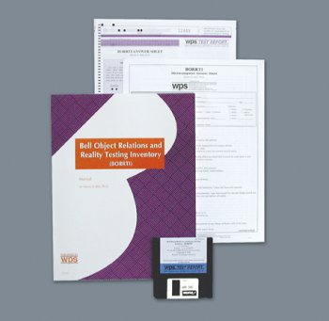
  At a Glance
  Purpose: | Quickly identifies adults with character disorders and psychoses and tells you which treatment methods are likely to be most effective
  Ages / Grade: | 18 and over
  Administration Time | 15 to 20 minutes
  Format: | Self-report
  Norms | Based on a nonclinical sample of 1,000 adults
  Related Products
  Bell Relationship Inventory for Adolescents (BRIA)
  Human Figure Drawing Test (HFDT)
  Logical Rorschach
  Psychiatric Diagnostic Screening Questionnaire (PDSQ)

This exciting self-report inventory gives clinicians a quick, convenient, and reliable way to evaluate adults with character disorders and psychoses. Administered in just 15 to 20 minutes, the BORRTI identifies clients with Borderline Personality Disorder and tells you which treatment methods are likely to be most effective. It is especially helpful when character pathology co-occurs with other problems, such as substance abuse or PTSD. It lets you know immediately whether the individual's problems are complicated by characterological deficits that could drastically alter the course of treatment.
Composed of 90 items, the inventory measures object relations and reality testing on seven scales:
Object Relations
- Alienation
- Insecure Attachment
- Egocentricity
- Social Incompetence
Reality Testing
- Reality Distortion
- Uncertainty of Perception
- Hallucinations and Delusions

If you are interested only in the items measuring Object Relations, you can use Form O, which includes just those items.
You can administer the BORRTI as part of an initial evaluation of the client. This gives you useful clinical information at the outset--and it instantly engages the individual in the therapeutic process. Clients seem to like the test, viewing it as evidence that you understand and are interested in their problems.
Scores from the full scale indicate the respondent's ability to sustain essential relationships and to accurately identify internal and external reality. Norms are based on a nonclinical sample of approximately 1,000 adults.

The test can be hand scored, using either the Full Form or Form O AutoScore Answer Form. It can also be computer scored, using WPS TEST REPORT prepaid Mail-In Answer Sheets, CD, or FAX Service. Each of these computer options gives you a full interpretive report. A Research CD, which offers scoring only, is also available.
The BORRTI test report profiles scores, describes client characteristics, makes diagnostic suggestions, and provides explicit, individualized treatment recommendations. It also alerts you to potential threats to the therapeutic relationship, and lists Specific Clinical Themes that apply to the client in question.
Quicker, more reliable, and easier to use than individually administered projective tests, the BORRTI simplifies what is often a difficult task--evaluating and treating clients with personality and thought disorders.

Component
KIT: Includes 20 Full Form AutoScore Forms; 2 WPS TEST REPORT prepaid BORRTI (Full Form) Mail-In Answer Sheets; Manual

