Burks Behavior Rating Scales, Second Edition (BBRS-2)

The BBRS-2 provides a quick, practical, and proven way to evaluate problem behavior in school children.
Purpose: | Provides a quick, practical, and proven way to evaluate problem behavior in school children
Ages / Grade: | Preschool through grade 12
Administration Time | 10 to 15 minutes
Format: | Parent or teacher rating scale
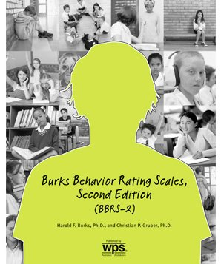

Related Products

Behavioral Summary
School Motivation and Learning Strategies Inventory (SMALSI)
Student Behavior Survey (SBS)
Conners Third Edition (Conners 3)

Burks Behavior Rating Scales, Second Edition (BBRS-2)
by Harold F. Burks, Ph.D.

This second edition of the Burks Behavior Rating Scales (BBRS) helps you diagnose and treat children with behavior problems. Administered and scored in minutes, these scales identify the nature and severity of pathological symptoms in children from prekindergarten through 12th grade (ages 4 through 18 years). This revision features updated norms, simpler and more efficient administration and scoring, and fewer scales for easier interpretation. All changes in this edition respect the strengths of the original BBRS and take into account the input of the many school psychologists who continue to use this assessment for effective and economical evaluation of disruptive and troubled children.
The BBRS-2 is available in two forms: the Parent form and the Teacher form. The test questions are the same for both groups, but each group has distinct test norms. Parent and Teacher Profile Sheets used for diagnostic purposes are included on their respective forms. The use of multiple raters in the BBRS-2 helps reduce bias and provides a more comprehensive understanding of the child's behavior problems.
The BBRS-2 includes 100 items, each describing a behavior infrequently observed in nonreferred children. A parent or teacher simply indicates, on a 5-point response scale, how often the behavior is seen in the child being evaluated.
The BBRS-2 produces seven scale scores:

- Disruptive Behavior
- Attention and Impulse Control Problems
- Emotional Problems
- Social Withdrawal
- Ability Deficits
- Physical Deficits
- Weak Self-Confidence

BBRS-2 scores can be used to:

1. Pinpoint personality areas that require further evaluation or treatment
2. Identify behaviors that may interfere with school functioning
3. Identify children who will (or will not) benefit from special education
4. Provide parents with information that is concrete, specific, and easy to understand

Normative data is based on a nationally representative sample of 2,864 individuals, including separate samplings of teachers (N = 1,481) and parents (N = 1,383). The BBRS-2 was validated on a clinical sample of 860 individuals; demonstrated strong internal consistency, retest reliability, and content validity; and was validated against widely used concurrent measures.
This useful revision offers a practical and proven way to identify problem behavior in children.

Component
KIT: Includes 25 Parent AutoScore Forms; 25 Teacher AutoScore Forms; Manual

