Child Symptom Inventory - 4 (CSI-4)
by Kenneth D. Gadow, Ph.D., and Joyce Sprafkin, Ph.D.

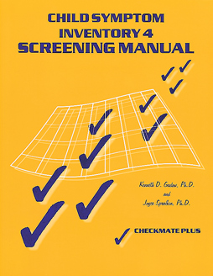
  Related Products
  Early Childhood Inventory-4 (ECI-4)
  Adolescent Symptom Inventory-4 (ASI-4)
  Bell Relationship Inventory for Adolescents (BRIA)

These two rating scales--one completed by the teacher, one by the parent--are used to screen 5- to 12-year-olds for symptoms of common childhood psychiatric disorders. Based on DSM-IV diagnostic criteria, these scales assist both educators and clinicians. They give schools a cost-effective way to convey clinically relevant information about the students they refer for evaluation or special services. And they give clinicians useful diagnostic information from parents and teachers. Completed and scored before the child sees the clinician, the CSI-4 makes it easier to conduct a focused, efficient interview, detect comorbid conditions, and make differential diagnoses.
The inventory offers both criterion-related cut-off scores and norm-based scores for determining symptom severity (low, moderate, or high, based on teacher and parent ratings of 6- to 12-year-olds).
A practical alternative to expensive, time-consuming psychiatric interviews, the CSI-4 lists symptoms of emotional and behavioral disorders specified in the Individuals with Disabilities Education Act (IDEA):

ADHD Dysthymia
Oppositional Defiant Disorder Asperger's Syndrome
Conduct Disorder Pervasive Developmental Disorder
Separation Anxiety Schizophrenia
Generalized Anxiety Obsessive-Compulsive Disorder
Social Phobia Posttraumatic Stress Disorder
Specific Phobia Motor Tic Disorder
Depression Vocal Tic Disorder

The Parent Checklist contains 97 items covering 17 disorders, while the Teacher Checklist contains 77 items related to 13 disorders. The teacher or parent rates each item on a 4-point response scale, indicating how often the symptom is observed in the child being evaluated. Responses are scored for symptom count and symptom severity. These two scores are compared to determine whether the child should be evaluated further.
The Checklists can also be computer scored. CSI-4 Software prints three reports: raw scores, scores above the cutoff, and a narrative describing the disorders associated with above-cutoff scores. These reports can be printed or sent to a text file for editing.
Completed in just 10 minutes, the CSI-4 integrates medical and educational classification systems. It gathers information from parents and teachers in a way that's compatible with the diagnostic system used by physicians and psychologists. This improves communication between the school and the mental health practitioner, and it provides the basis for a DSM-IV diagnosis--often required for reimbursement.

Component :

KIT: Includes 25 Parent Checklists; 25 Teacher Checklists; 50 Score Sheets; 50 Symptom Severity Profiles; Manual; 5-use Scoring CD

