PKBS–2: Preschool and Kindergarten Behavior Scales - Second Edition

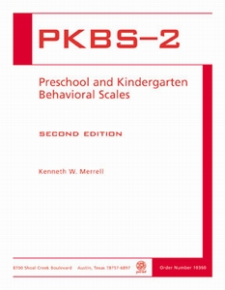

Ages: 3 through 6
Testing Time: 12 minutes
Administration: Individual

The Preschool and Kindergarten Behavior Scales-Second Edition (PKBS-2) is a behavior rating scale designed for use with children ages 3 through 6 years. This unique behavior rating scale is easy to use, very practical, and based on a solid foundation of research. With 76 items on two separate scales, it provides an integrated and functional appraisal of the social skills and problem behaviors of young children. The scales can be completed by a variety of behavioral informants, such as parents, teachers, and other caregivers.
Separate score conversion tables are available for home-based and school-based raters. Completion of the rating form takes about 12 minutes. The Social Skills scale includes 34 items on 3 subscales: Social Cooperation, Social Interaction, and Social Independence. The Problem Behavior scale includes 42 items on 2 subscales: Externalizing Problems and Internalizing Problems. In addition, 5 supplementary problem behavior subscales are available for optional use.
The PKBS-2 was standardized with a nationwide sample of ratings of 3,317 children ages 3 through 6. Ethnicity, socioeconomic status, and special education classification of the standardization sample are very similar to those characteristics of the U.S. population, based on the 2000 census. Internal consistency reliability ranges from .96 to .97 for the two scale totals and from .81 to .95 for the subscales. A wide variety of reliability and validity evidence in support of the PKBS-2 is included in the Examiner's Manual.

COMPLETE PKBS-2 KIT INCLUDES: Test Manual and 50 Test Forms, all in a sturdy storage box. (2003)

